**Output Web Pages**

**(Author I taken : George Eliot)**

Components used:

* Header
* Footer
* Images
* Hover Effect
* Teaser
* Search Bar

Home Page:

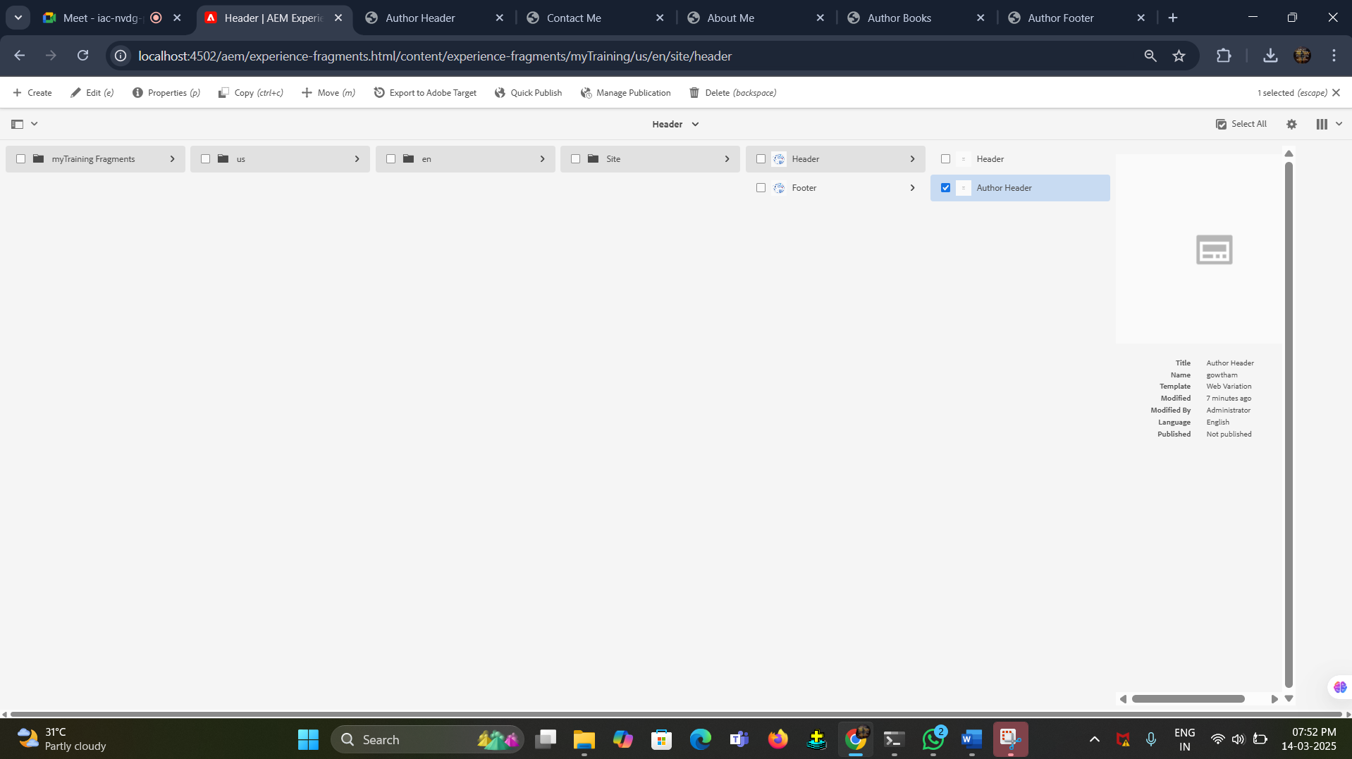

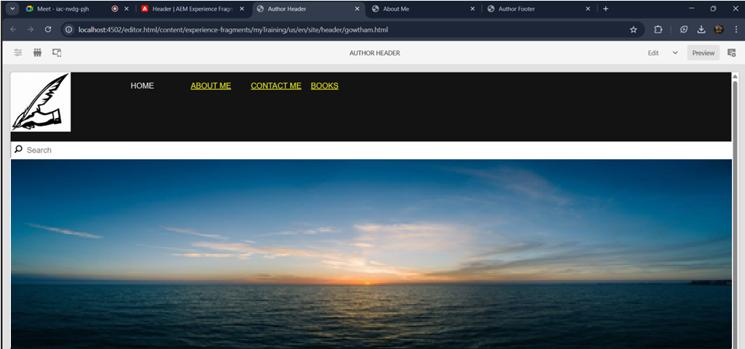

Awards creation:

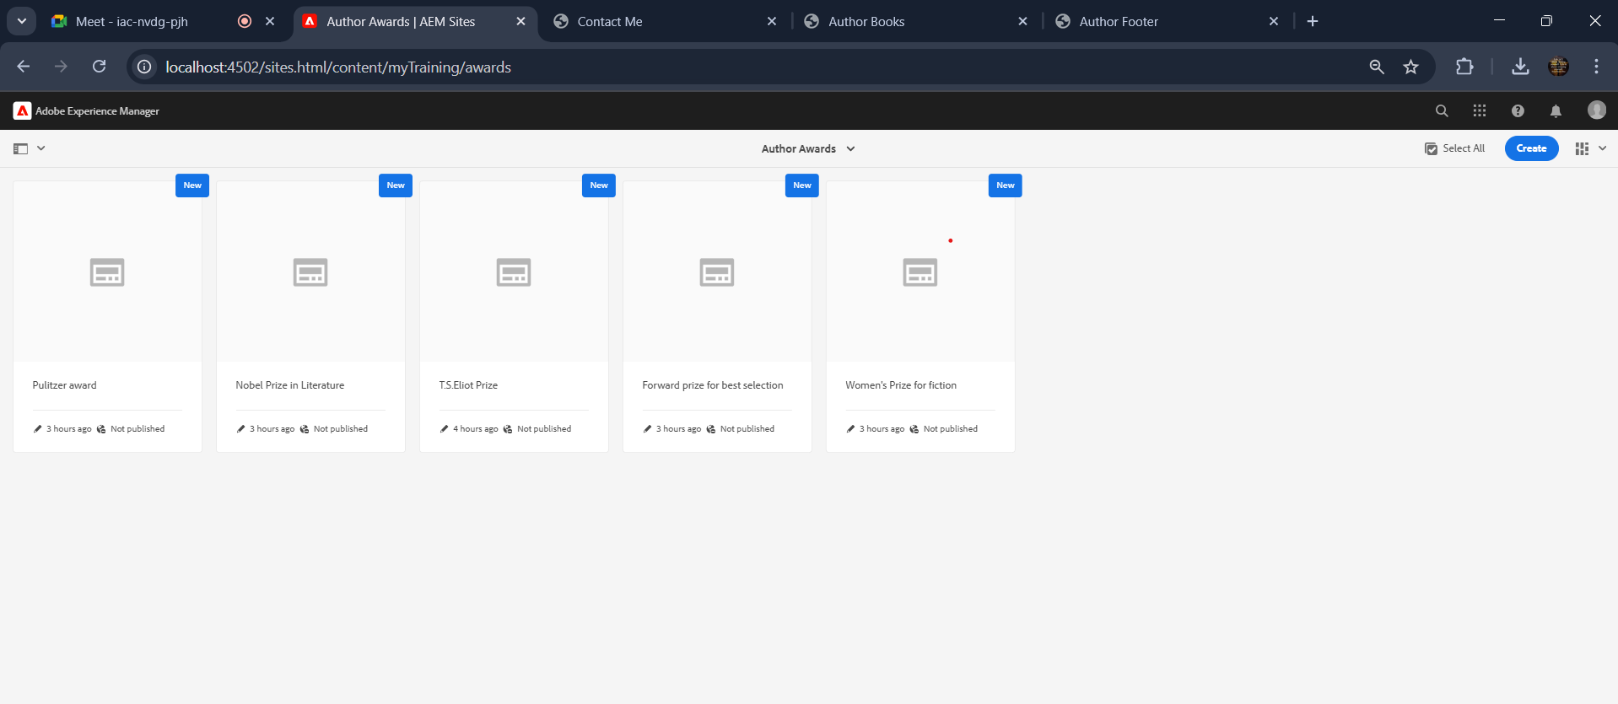

The Pulitzer Award(Sample 1):

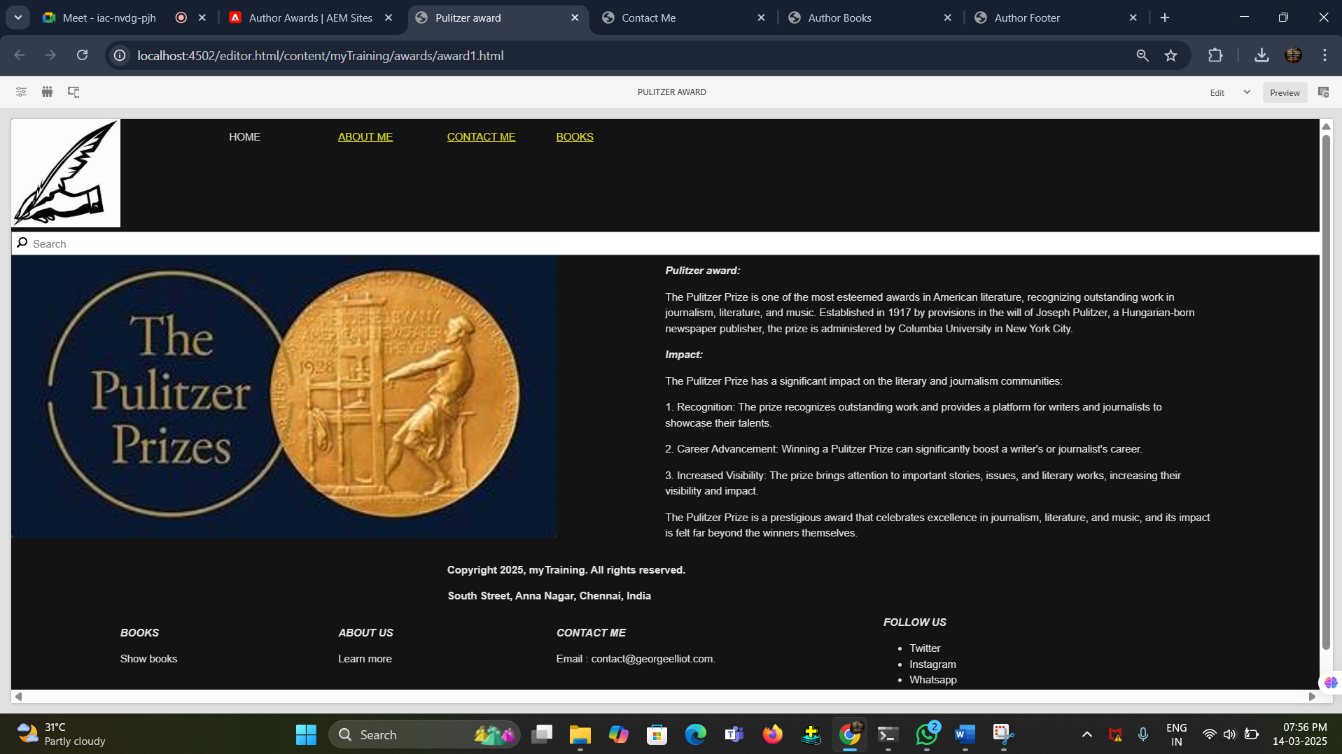

Nobel Prize for Literature(Sample 2):

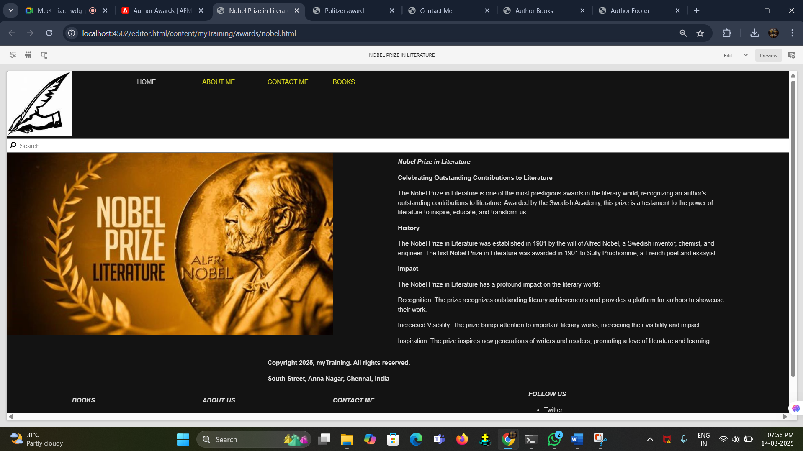

About Me Page:

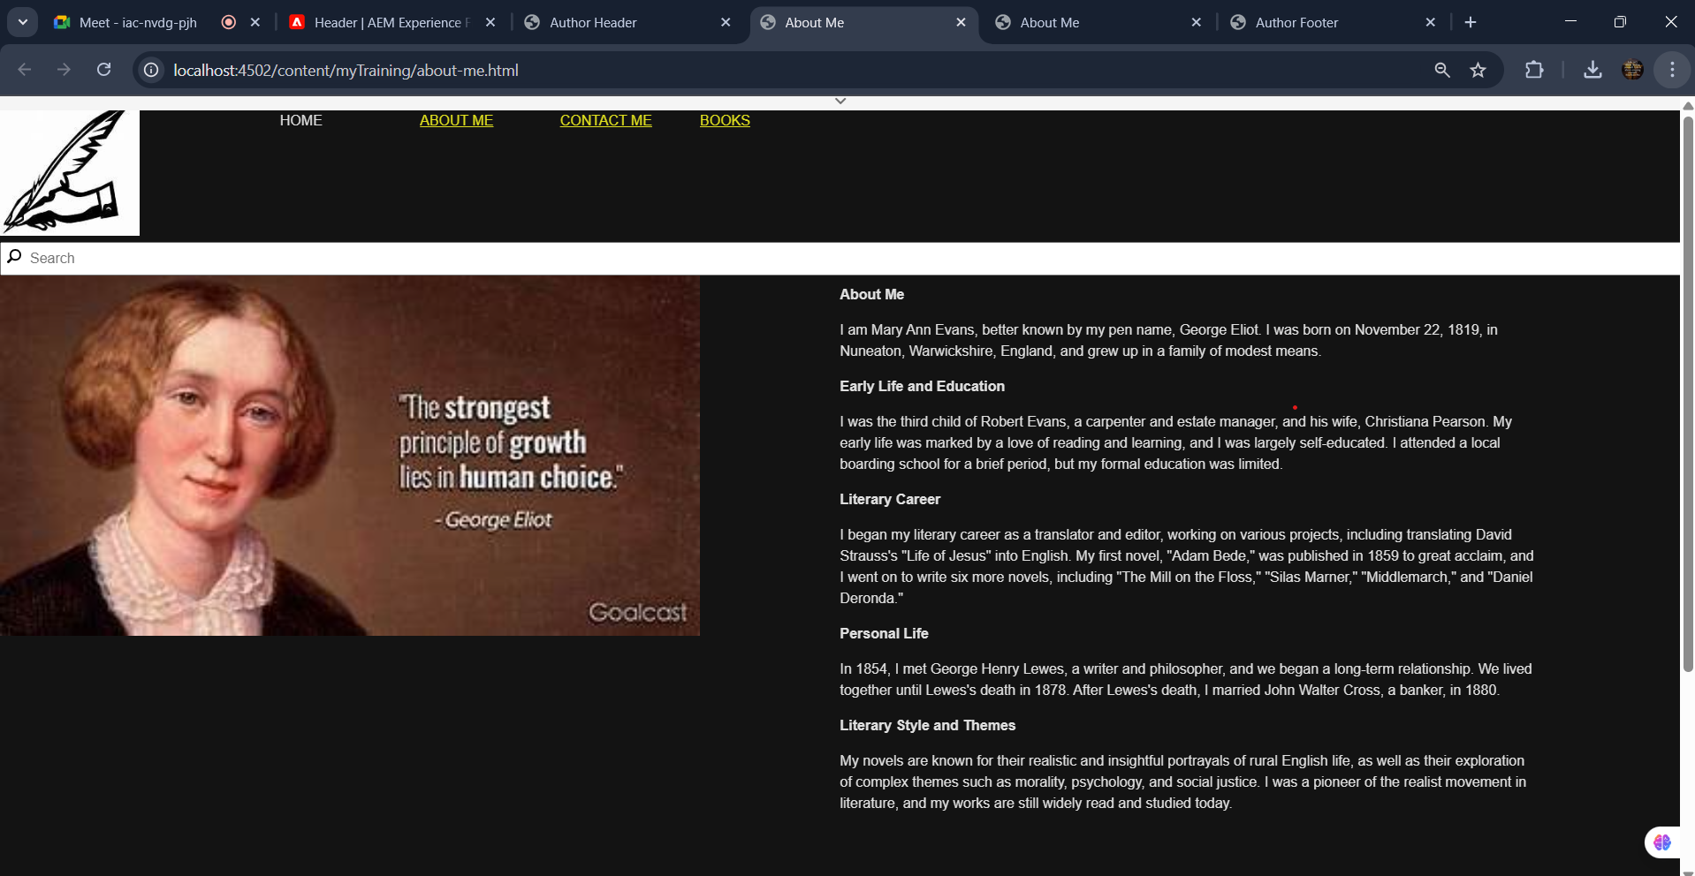

Books Page creation:

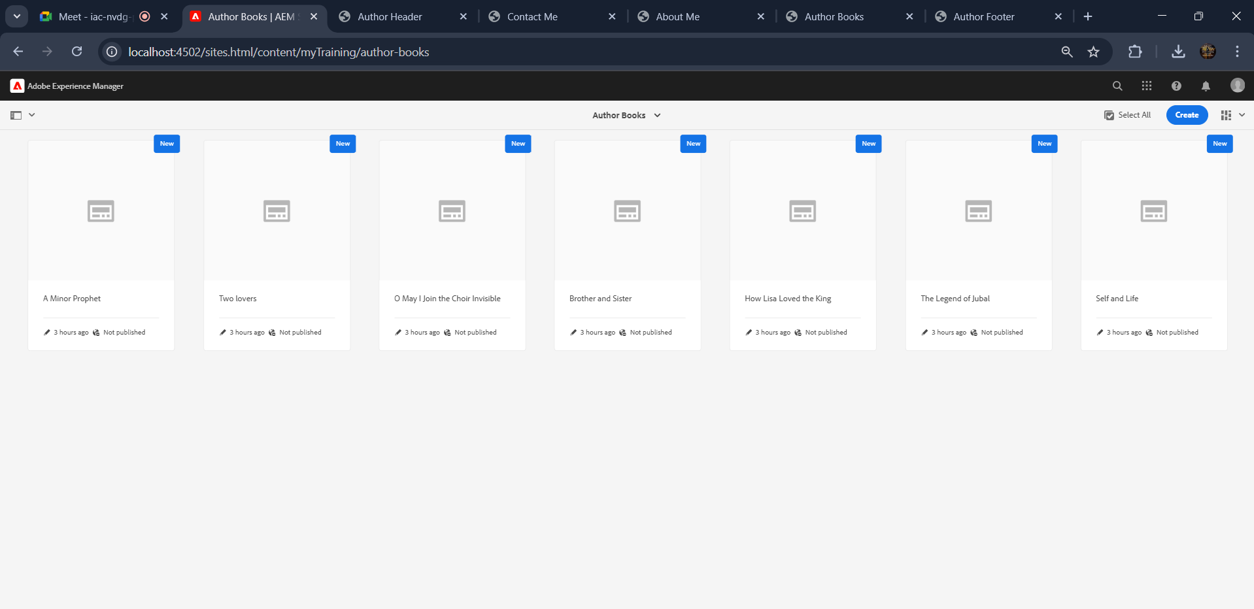

Book 1: The Minor Prophets

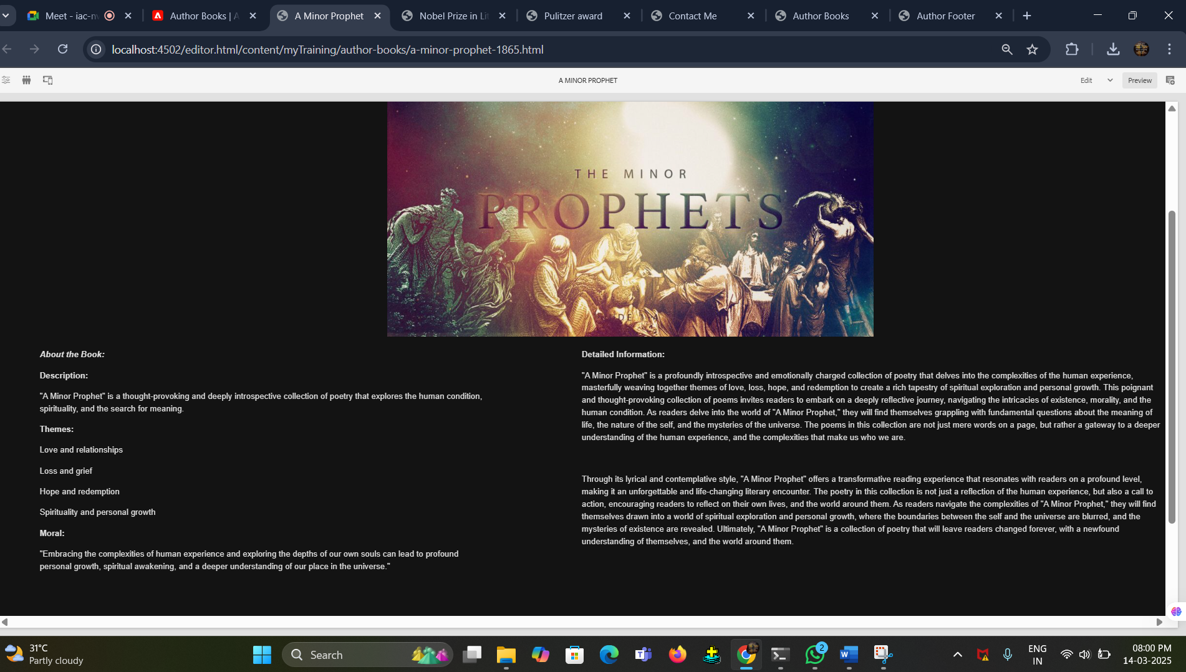

Book 2: Two Lovers

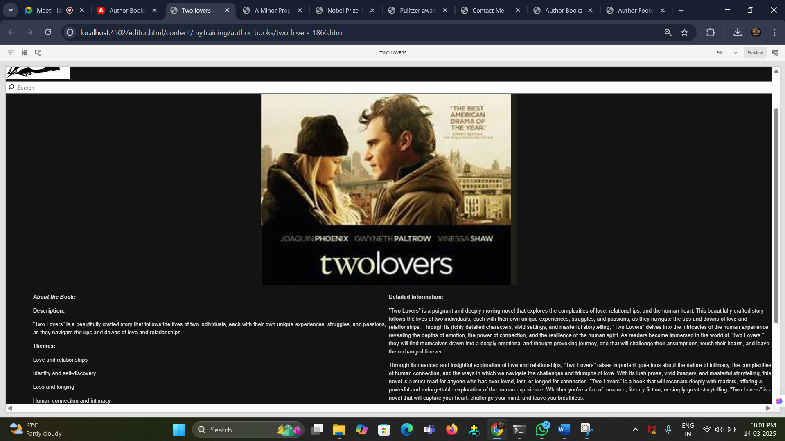

Book 3: O May I join the choir Invisible

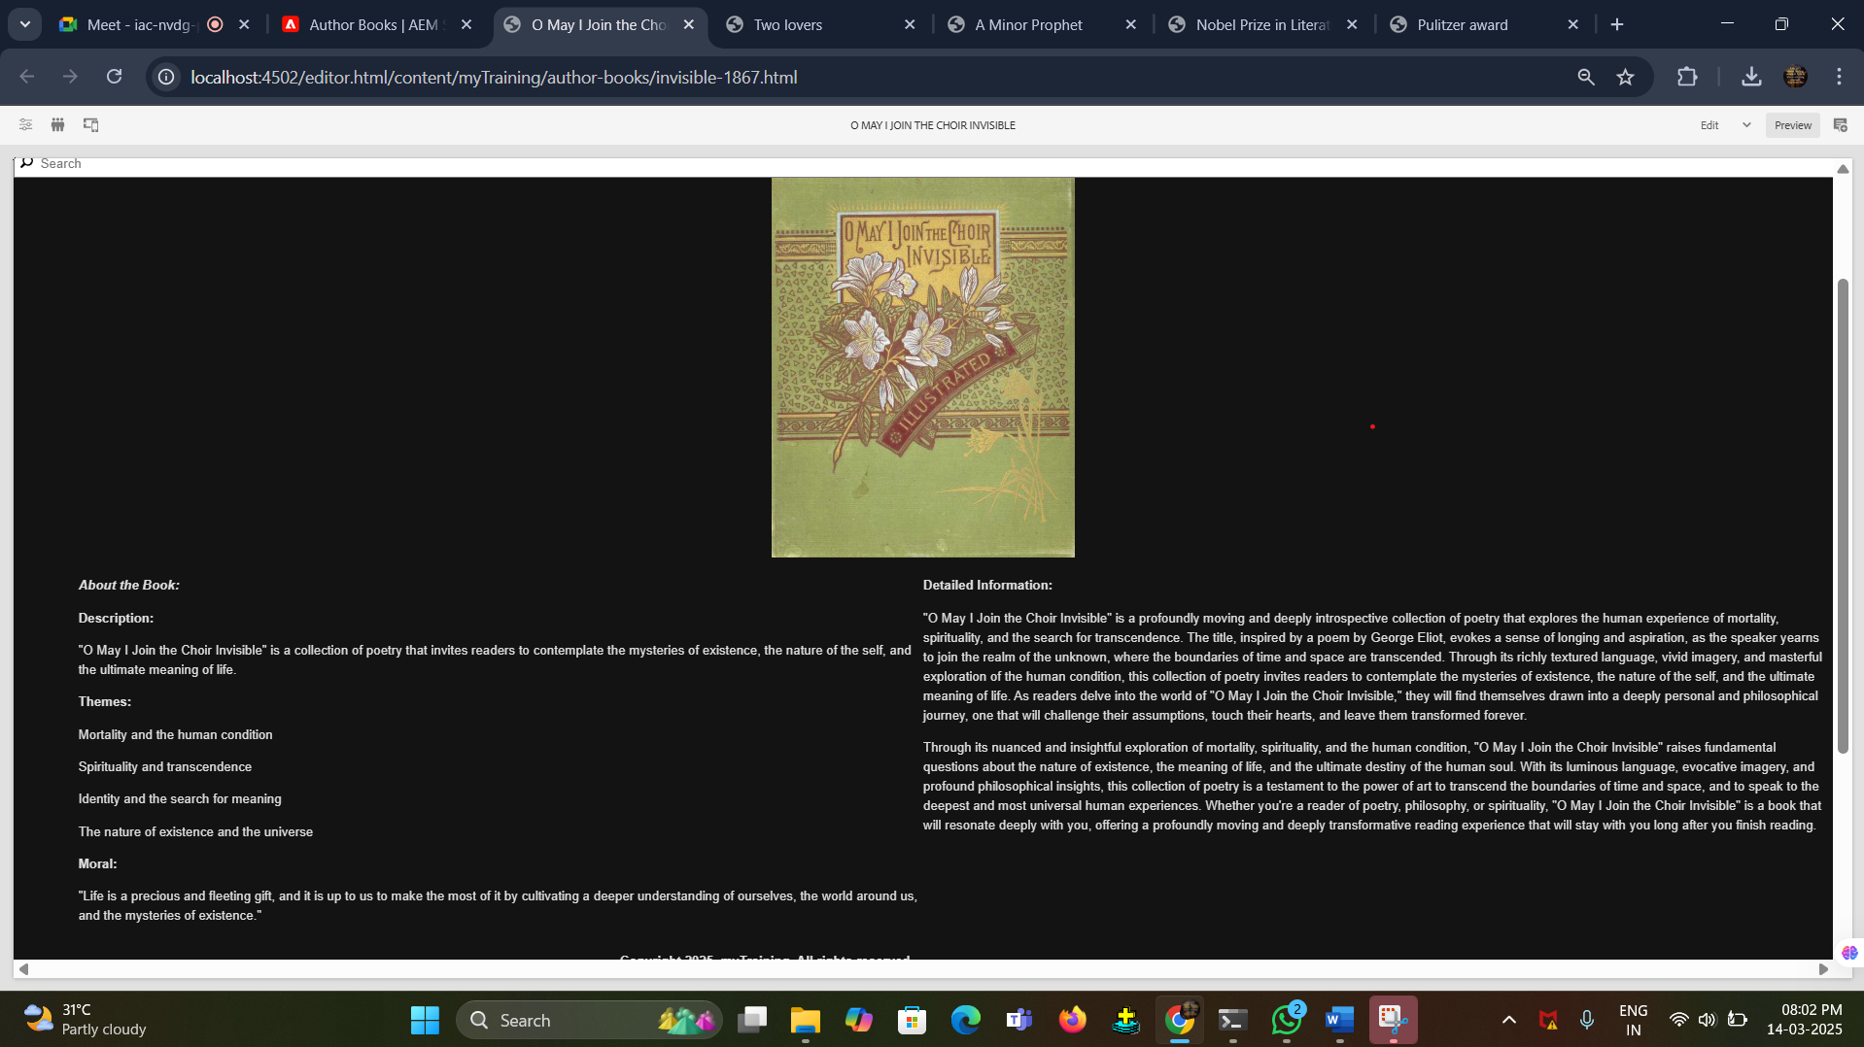

Book 4: Brothers and Sisters

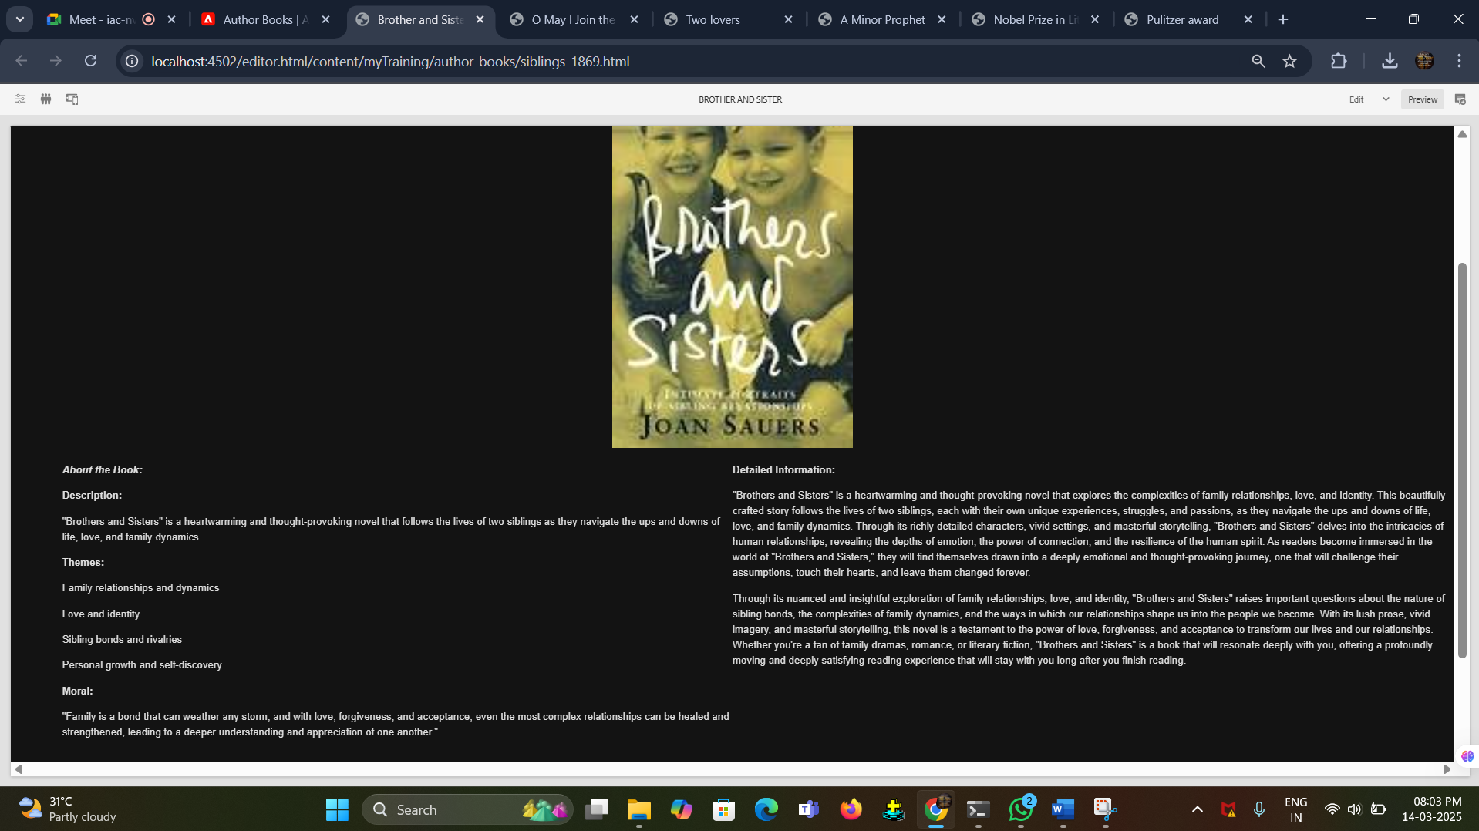

Contact Me Page:

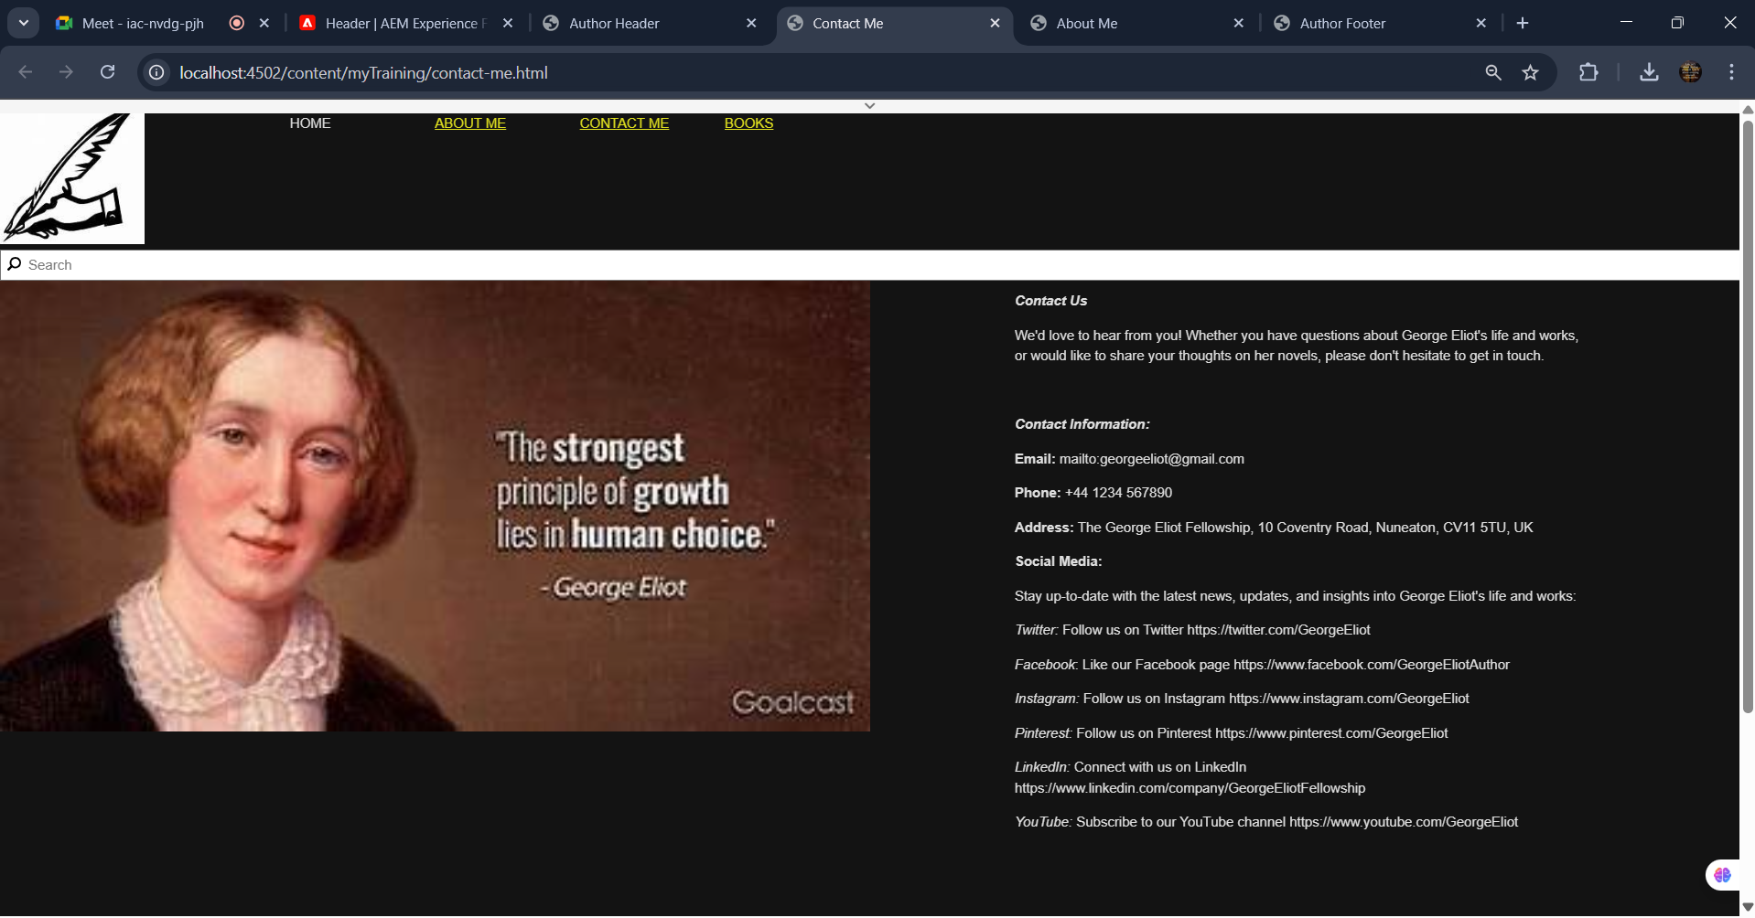

Footers section creation:

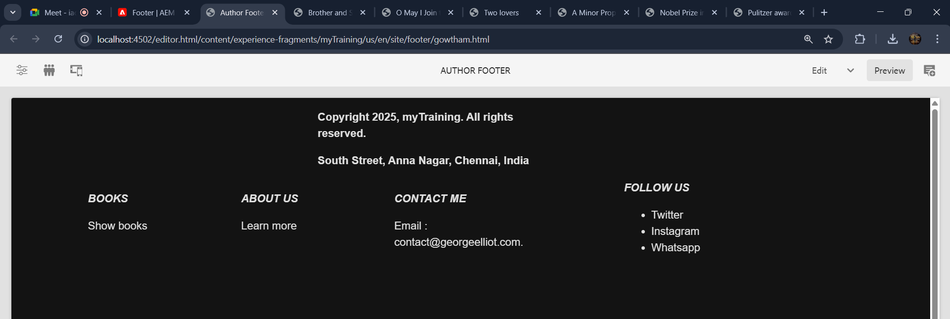

Headers section creation:

